MULTI TENANT SaaS RAG KNOWLEDGE ASSISTANT
Prepared for: Business Development & Tech Teams
Executive Summary
TechAssist AI is a production-grade, multi-tenant SaaS Knowledge Assistant designed to empower Business Development (BD) representatives. By combining Retrieval Augmented Generation (RAG) with strict data compliance and tenant isolation, it allows reps to ask complex technical client questions and receive grounded, accurate answers instantly.
A unique feature is the Dynamic Knowledge Gap Resolution loop, which empowers admins to detect unanswered questions, input missing context in real time, and immediately update the semantic vector space without code redeployment.
Core System Architecture & Design Decisions
The application follows a shared database, isolated context SaaS paradigm to ensure scalability, ease of maintenance, and absolute tenant security boundaries. The system isolates relational databases using SQL filters and segregates semantic index databases using tenant-specific collections.
1. Tenant Data Isolation
- Relational Data: Implemented via a shared PostgreSQL schema where every table (users, documents, queries, sessions, logs) is explicitly scoped by a tenant id foreign key. All queries are partitioned at the database layer.
- Vector Data: Each tenant gets a dedicated, isolated ChromaDB collection named kb_{tenant_id}. A tenant's search index is mathematically segregated, making cross-tenant data leaks impossible.
2. Ingestion & Chunking Strategy
- Parsing: Fast, synchronous document parser for PDF, DOCX, MD, and TXT files, structured to support files up to 10MB.
- Chunking: Uses LangChain's RecursiveCharacterTextSplitter with chunk_size=512 characters and chunk overlap=50 characters. This boundaries text at natural delimiters (paragraphs, sentences) to preserve context while maintaining semantic coherence.
- Batch Embedding Optimization: To prevent bottlenecks when loading large files, Ollama (nomic embed text) runs concurrent HTTP requests via a thread pool (max workers =10), sentence-transformers (all-MiniLM-L6-v2) uses batch encoding (batch_size=64), and ChromaDB batch upserts are limited to 100 chunks.
3. LLM Selection & Response Grounding
- Provider: Groq API using llama-3.3-70b-versatile for blazing-fast inference speed (< 1.5 seconds) and top tier reasoning capabilities.
- Grounded Answer: The LLM compiles answers under strict rules to ONLY reference context documents.
- Tone Rewriter: A secondary prompt rewrites technical jargon into plain, warm, client-friendly business terminology.
- Bridge Response: If context similarity falls below thresholds, a professional script is generated for the rep (e.g., 'What I can confirm is [Fact]. I want to make sure I give you the most accurate answer for [Detail] - I will verify with our tech team by tomorrow morning.').
4. Admin Feedback & Gap Resolution Loop
Instead of waiting for document updates, admins can act on 'Knowledge Gaps' (low confidence queries or thumbs down answers) instantly:
- Admins select an unanswered query in the dashboard and input the correct explanation.
- The backend appends this QA pair to resolved faq.txt inside the tenant's upload directory.
- The system automatically parses, chunks, deletes the old version's index from ChromaDB, and re-embeds the updated document.
- The vector store is instantly updated, and subsequent questions resolve with high confidence.
Core System Operations
Component | Technology | Implementation Details
Backend Framework | FastAPI + Uvicorn | Async request handling with Pydantic v2 schemas.
Relational Database | SQLAlchemy ORM | Driver compatibility for PostgreSQL (Prod) & SQLite (Local).
Vector Index | ChromaDB | Tenant-scoped persistent client indexing.
Rate Limiter | slowapi | Per-IP token-bucket limiter preventing LLM quota exhaustion.
Audit Logs | Custom Logger | Logs logins, uploads, deletions, ratings, and compliance exports.
User Interface | React + Vite | Dark-slate neomorphic dashboard designed for responsiveness.
The Query Lifecycle: Input to Response Flow
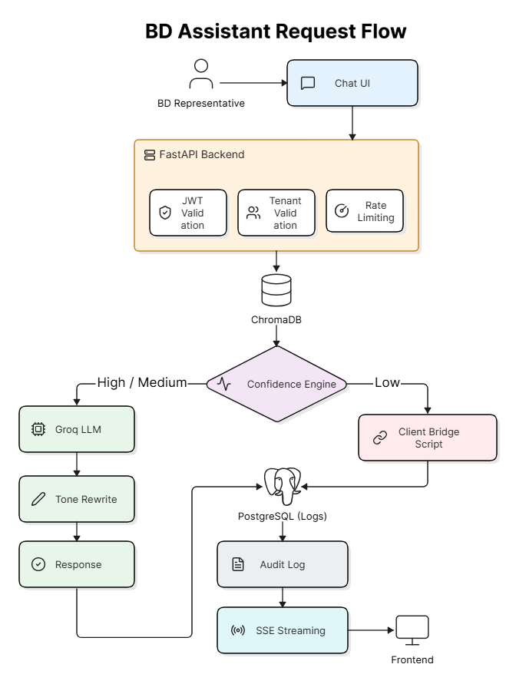
The following sequence illustrates how a query is processed from input to output

Conclusion
TechAssist AI transforms how non technical Business Development representatives handle complex client conversations. By combining Retrieval Augmented Generation with tenant isolated vector search and a confidence-driven response engine, the system delivers accurate, grounded answers in real time - eliminating the need for a technical team member in every meeting.

